**Risk and Resiliency Culverts Input Creation Instructions**

The Risk and Resiliency tool requires the CDOT maintenance culverts shapefile which has been joined with the traffic dataset from C-Plan utilizing a view in order to use the AADT in risk calculations. This view creates a join between datasets based on the Route, RefPt and EndRefPt fields in both datasets.

Instructions for creation of Culverts input dataset:

* Create a feature layer of the maintenance culverts you would like to use I the R&R model
* Start an ArcGIS Pro session, add your culverts layer
* Add the 2018 Traffic Data layer from C-Plan by clicking Map>Add Data>

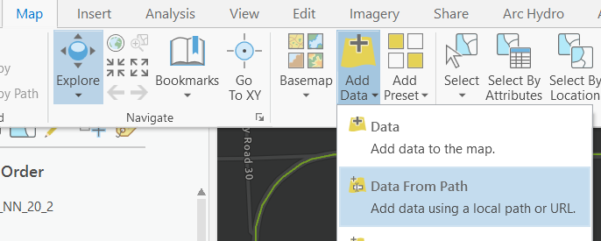

* Enter the following service URL: [https://dtdapps.coloradodot.info/arcgis/rest/services/CPLAN/open_data_sde/FeatureServer/16](https://urldefense.proofpoint.com/v2/url?u=https-3A__dtdapps.coloradodot.info_arcgis_rest_services_CPLAN_open-5Fdata-5Fsde_FeatureServer_16&d=DwMFaQ&c=sdnEM9SRGFuMt5z5w3AhsPNahmNicq64TgF1JwNR0cs&r=Xa-h8CwQ7xZ6BB4K9FIZCToXY9DzurbK9bfKqO0bZy8&m=XnWl--iOy80Vqjbmk9g2ZTyPYu77SEanbYwK_VIqScc&s=MCiQ4mKINsu63MHlhx6v8VZDmO6gq5BFp3sgcDETLuE&e=)
* Export this service to a local file
* To create the view our traffic and culverts layers must be housed on one of the enterprise databases.
* The file **CulvertsTrafficJoin.sql** will build your view if you place both files in the sandbox database under All_Regions
* Copy your culverts layer to sandbox or the db of your choosing using ArcGIS Pro
* Name your culverts layer CulvertPoorCriticalityHigh or rename All_Regions.dbo.CULVERTPOORCRITICALITYHIGH in the .sql file
* Name your traffic layer TrafficCounts or rename All_Regions.dbo.TRAFFICCOUNTS in the .sql file
* Open the .sql file in SQL Server Manager and run it to create you view. You can comment out the first three lines to take a look at the view before creating it.
* You should now have a table called CulvertsHighCritPoorCond_TrafficJoin. Bring this table into your ArcGIS Pro Project.
* Right click on CulvertsHighCritPoorCond_TrafficJoin and select Add X/Y Data. This will create the shapefile or feature class that you will use as your Culverts input.